**Projection of current usage**

**Overview**This project aims to develop a machine learning model that predicts where power consumption is happening based on the date, time, and consumed power. It is being developed as a proof of concept for a future large-scale project.

**Objective**To create an accurate and scalable ML pipeline that takes timestamped power data as input and outputs the location/source of consumption within a household or facility.

**Data Workflow**

* Source: Data description and guidelines provided by the company
* Generation: Synthetic raw data generated in .csv format
* Preprocessing:
  + Selected relevant columns: date, time, consumed_power
  + Created clean training datasets for model input
* Storage: Structured in /data/ directory (raw and processed formats)

**Model Development**

* Current Models Implemented:
  + LSTM (train_lstm.py)
  + XGBoost (train_xgboost.py)
  + Random Forest (train_randomforest.py)
  + Linear Regression (train_linear_model.py)
* Final Model Selection: Scheduled for Monday
* Feature Engineering: Custom time-based encoding using time_feature_encoder.py
* Testing: Robust framework under /test/ with unit tests and model evaluation scripts

**Deployment Plan**Following model selection, a dedicated application will be built using the chosen model to demonstrate end-to-end functionality and usability.

**Project Role**Serves as a proof of concept and technical demonstration for the company’s upcoming large-scale smart energy forecasting system**.**

**Project Structure**

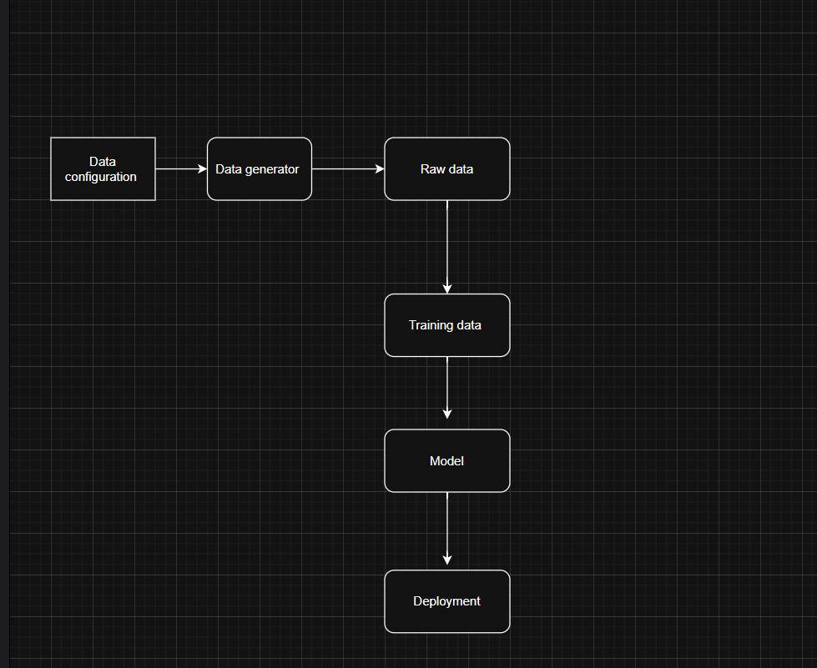

**Summary**  
This project presents a scalable and modular machine learning pipeline for accurate power consumption prediction. Its robust design, featuring a multi-model approach and flexible configurations, ensures adaptability across diverse datasets and deployment scenarios.